Module 7: Get started with natural language processing in Azure

Understand natural language processing on Azure
- Core NLP Tasks:
  - Language detection, sentiment analysis, named entity recognition, text classification, translation, and summarization.
- 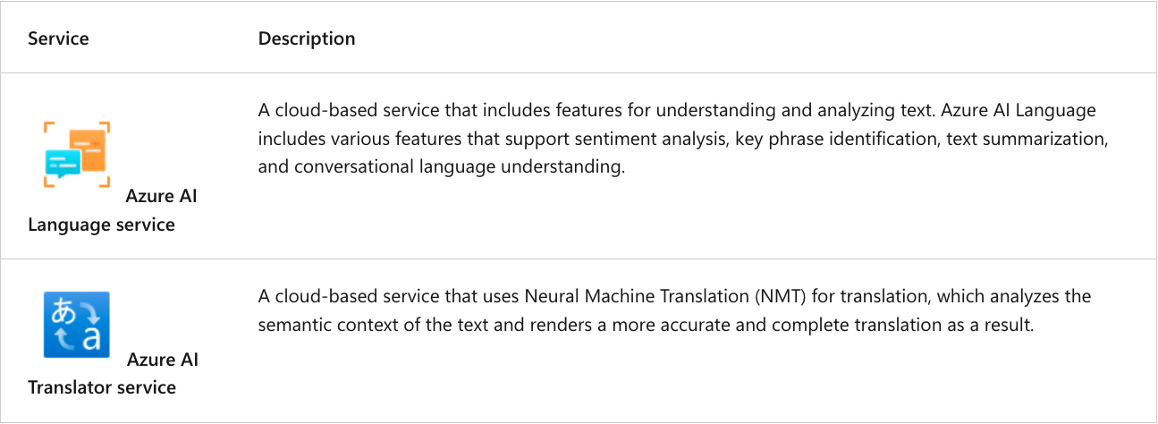

Azure AI Language's text analysis capabilities
- This resource type performs advanced natural language processing over unstructured text
  - General Features:
    - Named entity recognition – identify people, places, events, and more. This feature can also be customized to extract custom categories.
    - Entity linking – identify known entities together with a link to Wikipedia.
    - Personal identifying information (PII) detection - identify personally sensitive information, including personal health information (PHI).
    - Language detection – identify the language of the text and returns a language code such as "en" for English.
    - Sentiment analysis and opinion mining – identify whether text is positive or negative.
    - Summarization of text
    - Key phrase extraction lists the main concepts from unstructured text.

Entity recognition and linking
- Provide Azure AI Language with unstructured text and it returns a list of entities in the text that it recognizes (entity == item of a particular type/category).
- Examples:
  - 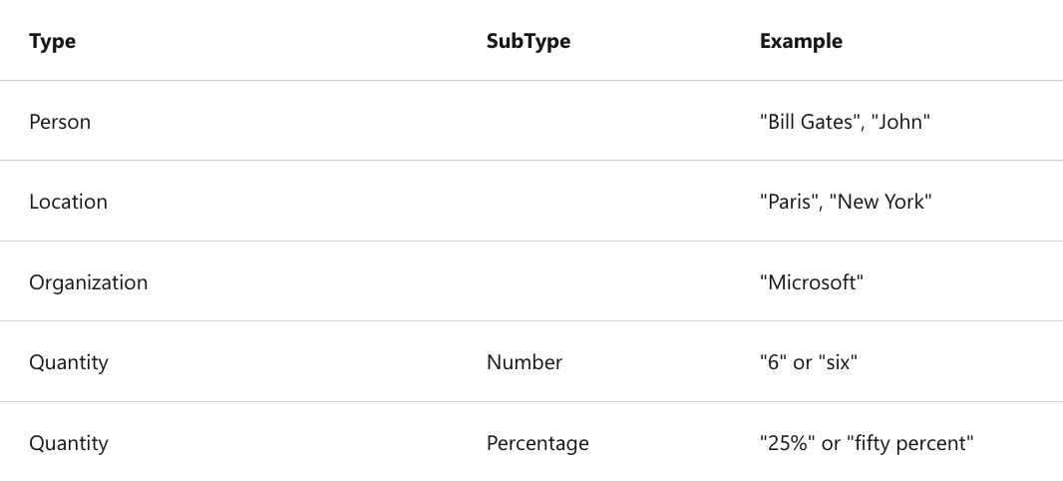
- Entity linking helps disambiguate entities by linking to a specific reference (ex. URL to relevant Wikipedia article.
  - 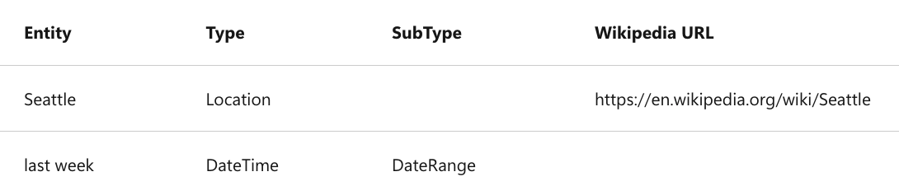

Language detection
- Identify the language in which text is written:
  - The language name (for example "English").
  - The ISO 6391 language code (for example, "en").
  - A score indicating a level of confidence in the language detection.
- 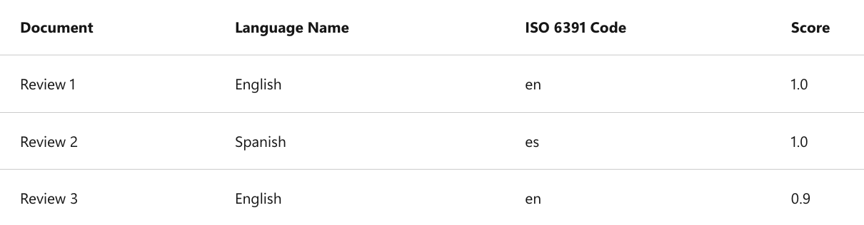
- The language detection service focuses on the predominant language in the text (if multiple languages used in sentence.

Sentiment analysis and opinion mining
- Evaluate text and return sentiment scores and labels for each sentence to check for positive or negative sentiment in social media, customer reviews, etc.
- Azure AI Language uses a prebuilt machine learning classification model to evaluate the text
  - 3 categories: positive, neutral, and negative (between 0 and 1)
    - Example: Review 1 – Document sentiment is positive
      - Positive score: 0.90 Neutral score: 0.10 Negative score: 0.00

Key phrase extraction
- You can use the key phrase extraction capabilities of the Language service to summarize the main points of a customer review
- Example:
  - 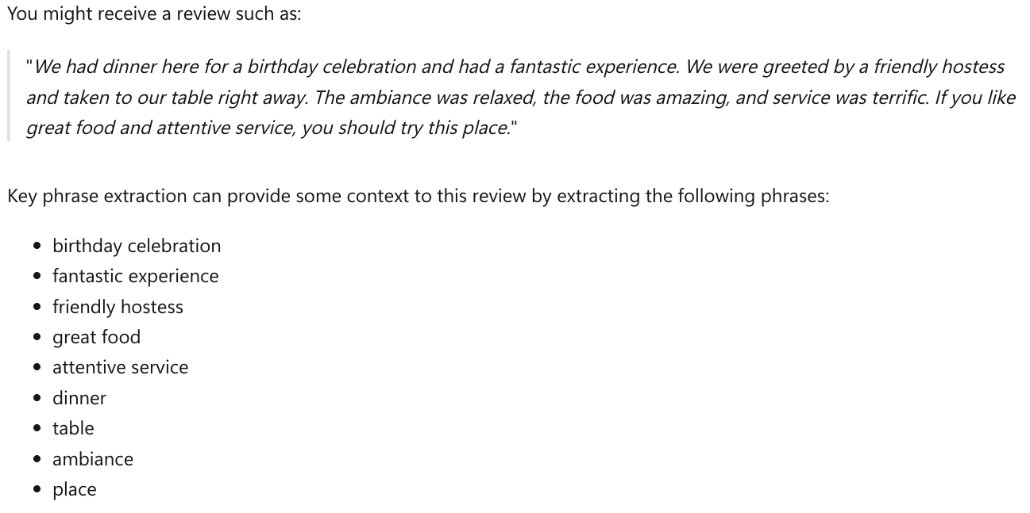

Azure AI Language's conversational AI capabilities
- Conversational AI describes solutions that enable a dialog between AI and a human.

Question answering (chat bot)
- Typically, question answering is used to build bot applications that respond to customer queries.
- Azure AI Language --> use custom question answering feature that enables you to create a knowledge base of question and answer pairs that can be queried using natural language input (CX input).

Conversational language understanding (CLU)
- Use CLU to build language models that interpret the meaning of phrases in a conversational setting.
  - Enables use of custom natural language understanding models to predict the overall intention of an incoming phrase and extract important information from it.
- Example: application is able to take in audio input such as, "Turn the light off", and understand an action it needs to take, such as turning a light off.

Azure AI Translator capabilities
- Azure AI Translator supports text-to-text translation between more than 130 languages.
- Specify one from language with multiple to languages, enabling you to simultaneously translate a source document into multiple languages.
  - It understands semantic meaning of text as well as the direct translation.

Azure AI Translator (Pro version exists too for enterprise use)
- Capabilities:
  - Text translation – used for quick and accurate text translation in real time.
  - Document translation – used to translate multiple documents across all supported languages while preserving original document structure.
  - Custom translation – used to enable enterprises, app developers, and language service providers to build customized neural machine translation (NMT) systems.

Get started in Azure AI Foundry
- Choose either a single-service resource or a multi-service resource.
  - Language resource – choose if you only plan to use Azure AI Language services, or if you want to manage access and billing for the resource separately from other services.
  - Translator resource – choose if you want to manage access and billing for each service individually.
  - Azure AI services resource – choose if you plan to use Azure AI Language in combination with other Azure AI services, and you want to manage access and billing for these services together.

